**Full Stack III - Lab 5**

* Buffers

**Developer Note:**

* Try to solve the problems without using search engines or stack overflow for the solutions.
* Create separate files for each exercise

**Exercise 1:**

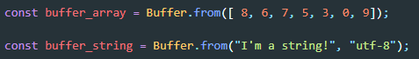

* Write node script file that use the above two buffers and does the following:
  + convert **buffer_string** to a **string** and output
  + convert **buffer_string** to **hex** and output
  + convert **buffer_string** to **utf-8** and read from **0 to 10**
  + join the **buffer_array** and **buffer_string** and output
  + convert the **joined_buffer** to **JSON** and output *(using* ***Buffer.concat****)*

**Output**

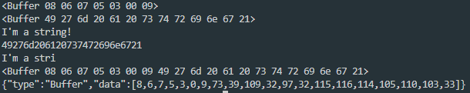

***Buffer - Decode to String - Reference*** [**https://nodejs.org/api/buffer.html#buffer_buf_tostring_encoding_start_end**](https://nodejs.org/api/buffer.html#buffer_buf_tostring_encoding_start_end) ***Buffer - Concatenation - Reference*** [**https://nodejs.org/api/buffer.html#buffer_class_method_buffer_concat_list_totallength**](https://nodejs.org/api/buffer.html#buffer_class_method_buffer_concat_list_totallength)

**Exercise 2:**



* Write a node script file that uses the buffer above and does the following:
  + creates a new **event emitter**
  + register an event emitter listener **'convert'**
  + when **'convert'** listener is called, a callback will iterate over the buffer elements and console log each string element
  + emits the **'convert'** event

***Event Emitter - Reference***

<https://nodejs.org/api/events.html#events_class_eventemitter>

***Buffer.from(array) - Reference***

<https://nodejs.org/api/buffer.html#buffer_class_method_buffer_from_array>

**Output** 